

ELECTRIC LINE CLEARANCE MANAGEMENT PLAN

**2021- 2027**

Version Control

|  |  |  |
| --- | --- | --- |
| Draft | Document date | Distributed |
| *Version 1* | *26/02/21* | *26/02/21* |
| *Version 2* | *05/03/2021* | *05/03/2021* |
| *Final* | *24/032021* | *2403/2021* |
| *Version update* | *11/07/2023* | *11/7/2023* |
| *Version update* | *01/05/240* | *01/05/24* |

Contents

STRUCTURE OF PLAN 5

DISTRIBUTION BUSINESSES 5

CONTRACTOR 5

PART 2 SECTION 9 PREPARATION OF A MANAGEMENT PLAN 6

9(2) Preparation of a Management Plan by March 31st 6

9(4) Management Plan requirements 7

9(4)(a) NAME, ADDRESS AND TELEPHONE NUMBER OF THE RESPONSIBLE PERSON: 7

9(4)(b) NAME, POSITION, ADDRESS AND TELEPHONE NUMBER OF THE PERSON WHO WAS RESPONSIBLE FOR THE PREPARATION OF THE PLAN: 7

9(4)(c) NAME, POSITION, ADDRESS AND TELEPHONE NUMBER OF THE PERSONS WHO ARE RESPONSIBLE FOR CARRYING OUT THE PLAN: 7

9(4)(d) THE TELEPHONE NUMBER OF A PERSON WHO CAN BE CONTACTED IN AN EMERGENCY THAT REQUIRES CLEARANCE OF AN ELECTRIC LINE THAT THE RESPONSIBLE PERSON IS REQUIRED TO KEEP CLEAR OF TREES OR PARTS OF TREES. 7

9(4)(e) THE OBJECTIVES OF THE PLAN: 8

9(4)(f) THE LAND TO WHICH THE MANAGEMENT PLAN APPLIES TO - MAPS 9

9(4)(g) ANY HAZARDOUS BUSHFIRE RISK AREAS AND LOW BUSHFIRE RISK AREAS IN THE LAND REFERRED TO IN PARAGRAPH (F); 9

9(4)(h) EACH AREA THAT THE RESPONSIBLE PERSON KNOWS CONTAINS A TREE THAT THE RESPONSIBLE PERSON MAY NEED TO CUT OR REMOVE TO ENSURE COMPLIANCE WITH THE CODE AND THAT IS – 9

9(4)(i) DETAILS OF METHODS THAT WILL BE USED TO AVOID AND MINIMISE THE IMPACT ON VEGETATION REFERRED TO IN PARAGRAPH 9(4)(h) 10

9(4)(j) THE MANAGEMENT PROCEDURES THAT THE RESPONSIBLE PERSON IS REQUIRED TO ADOPT TO ENSURE COMPLIANCE WITH THE CODE 11

9(4)(k) THE PROCEDURES TO BE ADOPTED IF IT IS NOT PRACTICABLE TO COMPLY WITH THE REQUIREMENTS OF AS 4373 WHILE CUTTING A TREE IN ACCORDANCE WITH THE CODE. 16

9(4)(l) A DESCRIPTION OF EACH ALTERNATIVE COMPLIANCE MECHANISM IN RESPECT OF WHICH THE RESPONSIBLE PERSON HAS APPLIED, OR PROPOSES TO APPLY, FOR APPROVAL UNDER CLAUSE 31 OF THE CODE. 18

9(4)(m) THE DETAILS OF EACH APPROVAL FOR AN ALTERNATIVE COMPLIANCE MECHANISM 18

9(4)(n) A DESCRIPTION OF THE MEASUREMENTS THAT MUST BE USED TO ASSESS THE PERFORMANCE OF THE RESPONSIBLE PERSON UNDER THE MANAGEMENT PLAN: 18

9(4)(o) DETAILS OF THE AUDIT PROCESSES THAT MUST BE USED TO DETERMINE THE RESPONSIBLE PERSON’S COMPLIANCE WITH THE CODE: 19

9(4)(p) THE QUALIFICATIONS AND EXPERIENCE THAT THE RESPONSIBLE PERSON MUST REQUIRE OF THE PERSONS WHO ARE TO CARRY OUT THE PRUNING OR REMOVAL OF TREES: 21

9(4)(q) NOTIFICATION AND CONSULTATION PROCEDURES 23

9(4)(r) DISPUTE RESOLUTION PROCEDURES. 23

Complaint Process and Timeframes 23

PART 2 – CLEARANCE RESPONSIBILITIES 26

DIVISION 1 – ROLE OF RESPONSIBLE PERSONS 26

(4) Exception to minimum clearance space for structural branches around insulated low voltage electric lines 26

(5) Exception to minimum clearance space for small branches around insulated low voltage electric lines 26

(6) Exception to minimum clearance space for SMALL branches around uninsulated low voltage electric lines in low bushfire risk areas 26

(7) Exception to minimum clearance space for structural branches around uninsulated low voltage electric lines in low bushfire risk areas 27

(8) Owner or operator of transmission line must manage trees around minimum clearance space 27

(9) Responsible person may cut or remove hazard tree 28

PART 2 – CLEARANCE RESPONSIBILITIES 28

DIVISION 2 – MANNER OF CUTTING AND REMOVING TREES 28

(9) Responsible Person may cut or remove hazard trees 28

(10) Cutting of tree to comply with Standard 28

(11) Cutting or removal of indigenous or significant trees must be minimised 28

(12) Cutting or removing habitat for threatened fauna 28

PART 2 – CLEARANCE RESPONSIBILITIES 29

DIVISION 3 – NOTIFICATION, CONSULTATION AND DISPUTE RESOLUTION 29

(16) Responsible person must publish notice before cutting or removing certain trees 29

DIVISION 4 – ADDITIONAL DUTIES OF RESPONSIBLE PERSONS 29

(20) Duty relating to the safety of cutting or removal of trees close to an electric line 29

PART 3 – MINIMUM CLEARANCE SPACES 29

DIVISION 2 - ALTERNATIVE COMPLIANCE MECHANISMS 29

(31) Application for approval of alternative compliance mechanism 29

(32) Formal safety assessment of alternative compliance mechanism 30

APPENDIX 1 – DECLARED AREA MAPS (1 of 3) 31

APPENDIX 1 – DECLARED AREA MAPS (2 of 3) 32

APPENDIX 1 – DECLARED AREA MAPS (3 of 3) 33

APPENDIX 2 - Notice of Urgent Cutting or Removal of Tree from unexpected regrowth or other reasons as per Clause 17 (2) (a), (b) and Clause 3 (a),(b),(c) of Electricity Safety (Electric Line Clearance) Regulations 2020 35

APPENDIX 3 - Applicable distance for middle two thirds of electric line span 36

**Disclaimer:**

This Electric Line Clearance Management Plan (‘Plan’) has been developed by the City of Melton to inform the Council, Energy Distribution Businesses (DB’s) and all other interested parties about the vegetation management processes and strategies undertaken by the City of Melton to care for its trees that are in the vicinity electricity assets. This Plan is to satisfy the requirements of the *Electricity Safety (Electric Line Clearance) Regulations 2020* (Vic).

City of Melton notifies users of this Plan that some of the content / statements made in this Plan are based on assumptions, estimates, predictions and projections made as part of the City of Melton’s Tree Management planning / development process and some of the content / statements are based on actions that the City of Melton intends to take in the future. The City of Melton may decide to take different actions to those it currently intends to take if circumstances change or assumptions and estimates prove to be inaccurate and events do not occur as predicted or projected. The users of this Plan accept responsibility and all risk for using material in this document. The users should seek expert advice in relation to their own circumstances and must rely solely on their own judgement and expert advice obtained.

The City of Melton does not guarantee and will not be liable for, whether in contract, tort (including negligence), equity or otherwise, to compensate or indemnify any person for any loss, injury or damage arising directly or indirectly from any person using, or relying on any content / statements in this Plan.

# STRUCTURE OF PLAN

The Electric Line Clearance Management Plan (Plan) has been structured to align with the relevant clauses of the Electricity Safety (Electric Line Clearance) Regulations.

The corresponding section of the Plan is numbered identically to the section of the Regulations to allow for cross referencing.

# DISTRIBUTION BUSINESSES

The names and contact details for the Distribution Businesses that operate within the City of Melton are:

**Jemena**

Contact Name: Tom Ruzeu

Role: Senior Asset Engineer, Performance and Bushfire

Address: PO Box 16182, Melbourne Collins St West, Vic 8007

Contact number: 1300 131 871

**Powercor**

Contact Name: Leo Hourigan

Role: Council Liaison Officer

Address: Locked Bag 14090, Melbourne, VIC 8001

Contact number: 13 22 06

# CONTRACTOR

Clearance works are undertaken by Council’s Contractor (the Contractor) under the following Contract (the Contract) –

* 22/20 Provision of Tree Maintenance Services

# PART 2 SECTION 9 PREPARATION OF A MANAGEMENT PLAN

## 9(2) Preparation of a Management Plan by March 31st

City of Melton is a Responsible Person required to prepare an Electric Line Clearance Management Plan for the purpose of the Regulations. This document is prepared in accordance with Section 9 of the Regulations.

The document has been prepared consistent with Council’s Environment Plan 2017 -2027. The Environment Plan provides the framework Council uses to manage the environmental impacts of its service delivery and operations and articulates how Council will work to improve environmental outcomes. The objectives outlined in this Electric Line Clearance Management Plan (Plan) are consistent with Council’s Tree Planting and Removal Policy, including the aim to minimise conflict with infrastructure.

The implementation and review of the Plan is part of Council’s strategic reporting framework and is reported within the Business Unit’s monthly report.

* Council will conduct a review by the 31st March annually to address any changes in personnel, policy or programs.
* Council will remove the superseded plan from the website at the same time as the new annual Plan is uploaded, not later than July 1 of each year.
* A complete review of the Plan will also be implemented should there be a change of Contractor or Contract methodology. This review could occur at any time.
* The amended Plan and the requirement to comply with the Plan will be brought to the attention of Council’s contractors annually at the monthly contract meeting following the review.
* The amended Plan and the requirement to comply with the Plan will be brought to the attention of relevant Council personnel following each annual review.

Council reviews the Electric Line Clearance Management Plan prior to the March 31st deadline each year to confirm compliance requirements and the status of the Plan’s implementation. Council will prepare a new or amended plan as required by March 31st each year. Such reviews will be recorded and reported to Council’s Authorising Officer.

The Plan is stored in Council’s document management system and will be available on the Council’s website [www.melton.vic.gov.au](https://www.melton.vic.gov.au/Home) from this date each year.

No exemptions are in operation and therefore none are required to be displayed.

## 9(4) Management Plan requirements

### 9(4)(a) NAME, ADDRESS AND TELEPHONE NUMBER OF THE RESPONSIBLE PERSON:

Name and Position: Roslyn Wai, CEO, City of Melton

Address: 232 High Street, Melton 3337

Telephone Number: 9747 7200

The CEO is Council’s principal representative in its role as a Responsible Person under the Electricity Safety Act 1998.

### 9(4)(b) NAME, POSITION, ADDRESS AND TELEPHONE NUMBER OF THE PERSON WHO WAS RESPONSIBLE FOR THE PREPARATION OF THE PLAN:

Name and Position: Colin Marshall, Acting Operations Manager

Address: 232 High Street, Melton 3337

Telephone Number: 9747 7200

### 9(4)(c) NAME, POSITION, ADDRESS AND TELEPHONE NUMBER OF THE PERSONS WHO ARE RESPONSIBLE FOR CARRYING OUT THE PLAN:

Name and Position: Steven Flaviano, Urban Forester

Address: 98-100 High Street, Melton 3337

Telephone Number: 9747 7200

### 9(4)(d) THE TELEPHONE NUMBER OF A PERSON WHO CAN BE CONTACTED IN AN EMERGENCY THAT REQUIRES CLEARANCE OF AN ELECTRIC LINE THAT THE RESPONSIBLE PERSON IS REQUIRED TO KEEP CLEAR OF TREES OR PARTS OF TREES.

EMERGENCY TELEPHONE No: 9747 7200 (24 hours, 7 days a week)

### 9(4)(e) THE OBJECTIVES OF THE PLAN:

*The following are identified as the key objectives of this Plan:*

* To ensure public safety at all times in relation to fire risk, human injury and continuity of supply resulting from the contact between power lines and vegetation.
* Where reasonably practicable and within their level of competence, Council employees and contractors will aim to ensure Electricity Safety.
* To achieve compliance with the Electricity Safety Act 1998 and the Electricity Safety (Electric Line Clearance) Regulations 2020 and the incorporated Code of Practice.
* To maintain the health and amenity of the community’s trees by applying appropriate standards and practices. Where practicable within the limitations imposed by the Regulations our tree management will be best industry practice.
* In the unlikely event that compliance cannot be readily achieved by pruning, Council will implement a documented process of 6-monthly inspections on these trees while developing an alternative engineering solution in conjunction with the Distribution Business.
* To ensure protection of areas of important local and significant vegetation throughout the Council’s Declared Area. This protection includes, but is not limited to, sites containing botanically, historically or culturally important vegetation, or vegetation of outstanding aesthetic or ecological significance, and/or the habitat of rare or endangered species.
* Establishing an open dialogue with relevant distribution company(s) vegetation management group to ensure both parties have a clear understanding of each other’s priorities. This will be achieved through an annual meeting with relevant distribution company(s) managers and City of Melton’s responsible employee(s).
* To ensure effective management of vegetation to maximise the amenity value of the City’s trees and ensure shading of pathways is continually increased to encourage physical activity in the community.
* To ensure provision of a safe working place for employees and contractors undertaking vegetation clearance pruning and any employee or contractors who conduct other maintenance vegetation works within the vicinity of powerlines.
* To ensure community satisfaction with the manner in which the necessary works are carried out.

Compliance with these objectives is measured by an ongoing process of auditing and Contract performance monitoring as detailed in [9(4)(n)](#_9(4)(n)_A_DESCRIPTION) of this Plan.

### 9(4)(f) THE LAND TO WHICH THE MANAGEMENT PLAN APPLIES TO - MAPS

The land to which this plan applies is shown in the three maps listed in Appendix 1. All the Declared Area managed by Council is rated Low Bushfire Risk Area (LBRA) based on the CFA Fire Hazard Ratings.

Council has an inventory of street trees and has identified that that there are ~3,300 trees in the vicinity of powerlines in the Declared Area.

The Municipal Fire Management Planning Committee meet quarterly with the local CFA brigade management. Any relevant amendments to the boundary or Hazardous Bushfire Risk Areas (HBRA) are discussed at these meetings.

### 9(4)(g) ANY HAZARDOUS BUSHFIRE RISK AREAS AND LOW BUSHFIRE RISK AREAS IN THE LAND REFERRED TO IN PARAGRAPH (F);

There is no Hazardous Bushfire Risk Area (HBRA) within the Declared Area managed by the City of Melton.

### 9(4)(h) EACH AREA THAT THE RESPONSIBLE PERSON KNOWS CONTAINS A TREE THAT THE RESPONSIBLE PERSON MAY NEED TO CUT OR REMOVE TO ENSURE COMPLIANCE WITH THE CODE AND THAT IS –

##### (i) Indigenous to Victoria

For the purposes of this Plan, indigenous vegetation means species locally indigenous to the Council area and does not include commercial and ornamental Australian native species, which are commonly planted as street trees, even where those species may be indigenous to other parts of Victoria.

Council’s Declared Area consists of mixed local native species, commercial native varieties and introduced species. Areas of historical, cultural, environmental, ecological and aesthetical importance have been identified throughout the municipality and included as Heritage and Environmental Significance Overlays in Council’s Planning Scheme.

There are no known trees of habitat significance for rare or endangered species listed in Council’s Declared Area within the vicinity of powerlines that require pruning or clearing to ensure compliance with the Code of Practice.

As there has been a long-term and ongoing powerline clearance program around existing trees, there are no known native trees that will be adversely affected by future works.

Additional resources available to identify significant native trees are -

1. Reference to the Heritage Register as per the meaning of the Heritage Act 1995 <http://vhd.heritagecouncil.vic.gov.au/>
2. Reference to the National Trust Register and regular communication with the Local History Officer <http://trusttrees.org.au/>
3. Reference to the Threatened Species Advisory Lists as published by the relevant State department [https://www.environment.vic.gov.au/conserving-threatened-species/threatened-species-advisory-lists](https://www.environment.vic.gov.au/conserving-threatened-species/threatened-species-advisory-lists%20)

No additional trees of significance have been identified since the previous Plan.

To improve planning outcomes Council will also liaise with the relevant distribution company(s) to obtain spatial data of the powerline assets in the Declared Area and incorporate this into its Geographic Information System (GIS).

The person responsible for the preparation of the Plan is by Council’s Environmental Planner on any relevant changes to native vegetation mapping, controls and other relevant matters. The amended Plan and any changes as a result of this briefing will be raised with Council’s contractors at the contract meetings.

##### (ii) Listed in planning scheme to be of ecological, historical or aesthetic significance

Based on the historical annual line clearance program, no trees of significance have been identified in the Declared Area that will be affected by electric line clearance.

By their nature, these types of vegetation do not change quickly in normal circumstances. Council will review the resources listed in [9(4)(h)(i)](#_9(4)(h)_EACH_AREA) and (ii) on an annual basis and undertake a review of the lists when the ELCMP is viewed annually.

No additional trees of significance have been identified since the previous Plan.

##### (iii) Trees of cultural or environmental significance

Trees of Cultural or Environmental Significance for the purposes of the Plan are defined as any tree protected as Significant or Heritage by relevant State legislation or local planning controls. Based on the historical annual line clearance program, there are no identified areas of special or cultural vegetation identified in the Declared Area that will be affected by electric line clearance.

By their nature, these types of vegetation do not change quickly in normal circumstances. Council will review the Planning Scheme and consult with Council’s Planning Department to identify any changes in State controls when this Plan is revised. The amended Plan and any changes as a result of this briefing will be raised with Council’s contractors at the monthly contract meetings.

No additional trees of significance have been identified since the previous Plan.

### 9(4)(i) DETAILS OF METHODS THAT WILL BE USED TO AVOID AND MINIMISE THE IMPACT ON VEGETATION REFERRED TO IN PARAGRAPH 9(4)(h)

As there has been an ongoing powerline clearance program around existing trees, there are no known trees from clause [9(4)(h](#_9(4)(h)_EACH_AREA)) that will be significantly adversely affected by future powerline clearance works.

There are no known trees of habitat significance for rare or endangered species listed in Council’s Declared Area within the vicinity of electric lines that require pruning or clearing to ensure compliance with the Code of Practice. The presence of any previously unidentified tree of significance will be reviewed as part of the annual review of this Plan using the processes and resources outlined in 9(4)(h).

Council has undertaken a tree inventory of street trees within the Declared Area encompassing Kurunjang East, Melton, Melton South and Diggers Rest. This has assisted Council in identifying that there are currently no trees of significance affected.

In the unlikely event a previously unidentified specimen of high value, or a tree with or likely to contain habitat hollows, is identified by Council or its Contractors as being non-compliant, the tree will be individually assessed to ensure that pruning is minimised and the environmental value of the tree is preserved. This may include managing the tree in line with Clauses 4, 5 or 6 of the Code, on an increased inspection or pruning cycle. If any are identified in the future, they will be plotted on Council’s mapping system and monitored to ensure that impacts are minimised if powerline clearance work is required. If Council intends to cut or, on the advice of a suitably qualified arborist, remove a tree that has been identified in 9(4)(h) as known habitat for fauna listed as –

a) threatened in accordance with section 10 of the Flora and Fauna Guarantee Act 1988 or

b) listed in the Threatened Invertebrate Fauna List with a conservation status in Victoria of vulnerable", "endangered" or "critically endangered"

Council will undertake cutting or removal of the tree outside of the breeding season for that species. Where it is not practicable to undertake cutting or removal of the tree outside of the breeding season for that species, translocation of the fauna will be undertaken wherever practicable.

In exceptional circumstances, fauna may be required to be relocated. This is not Council’s preferred option and will be used only as a last resort, for example, if the tree is assessed to be a hazard tree.

All pruning will take place in accordance with industry Best Practice and where practicable, pruning may be undertaken using Elevated Work Platforms (EWPs) or other similar methods to minimise overall site damage. Council will, as far as practicable, restrict cutting or removal of native trees or of cultural or environmental significance to the minimum extent necessary to ensure compliance with the requirements of the Code, the schedule to the Code or to make an unsafe situation safe.

All records will be filed in Council’s GIS system (Assetic) and kept for a minimum of 5 years.

### 9(4)(j) THE MANAGEMENT PROCEDURES THAT THE RESPONSIBLE PERSON IS REQUIRED TO ADOPT TO ENSURE COMPLIANCE WITH THE CODE

#### Include details of the methods to be adopted for managing trees and maintaining a minimum clearance space as required by the Code:

* + - 1. Identification of Work Required

Council has in place an annual inspection and pruning program for trees within the vicinity of powerlines in the Declared Area. This annual inspection program is a key tool in ensuring that trees are pruned on a regular basis and clearance spaces are maintained whilst ensuring tree amenity is considered.

The annual assessment and pruning of trees in the vicinity of powerlines is undertaken by September 30 and the pruning works are completed by November 30 each year. Typically, ~800 trees are pruned per annum. This is undertaken under the Contract.

This assessment is undertaken by an arborist experienced in tree identification and management employed by Council’s Contractor and is a key deliverable of the Tree Maintenance Contract. Each tree assessed is recorded in the Contractor’s electronic management system. Reports of the assessment are provided to Council as part of the monthly Contract report.

Trees that the Contractor believes cannot be successfully pruned in accordance with the Code will be brought to the attention of Council. The Council will then inspect the tree and if they believe the tree cannot be pruned to comply with the Code, Council will investigate and implement an alternative method to ensure safety and continuity of supply.

The Contractor will also assess:

* The voltage and length of the span to determine the correct Applicable Distance for clearance for the middle 2/3 of each span.
* The species of the vegetation to ascertain the regrowth potential.
* The tree for any other potential hazards.

In addition, any trees that are determined to be likely to breach the Code within the inspection cycle are also to be identified. This inspection also includes the identification of any hazards outside the clearance and regrowth spaces that may require assessment or correction. Each inspection shall be fully documented in the maintenance management system that the contractor has in place. Records of each tree and pruning undertaken on each tree are recorded in Council management system.

Hazardous trees identified during these routine inspections are programmed for pruning or removal and scheduled for according to their hazard potential.

Reports of non-compliance from relevant distribution company(s), residents or other sources will be investigated by a suitably qualified Council employee or contractor. Once the investigation has been completed a Contractor will carry out any pruning action to rectify a confirmed non-compliance.

Where necessary, the Council Supervisor will liaise with the Contractor to determine the cause of the non-compliance. Where the non-compliance is a failure to follow the Contract specification, this will be documented as a contact non-conformance in the monthly Contract meeting. Where the non-compliance is caused by unanticipated regrowth, the species and growing conditions will be identified to determine if this is likely to occur again, or with other trees in the vicinity of powerlines. Appropriate inspection regimes will be implemented to address any identified issues.

Consultation is undertaken as required with the distribution business representatives shown on page 5 to maintain open communication and discuss clearance issues regarding the following:

* + Requesting of assistance for suppressions and shutdowns.
  + Changes to regulations.
  + Urgent or non-compliant works.
  + Other issues as they arise.
    - 1. Hazard Trees

The Electricity Safety Act 1998 (Victoria) Section 86B provides that a municipal council must specify, within its Municipal Emergency Management Plan (MEMP):

1. procedures and criteria for the identification of trees that are likely to fall onto, or come into contact with, an electric line (hazard trees); and
2. procedures for the notification of responsible persons of trees that are hazard trees in relation to electric lines for which they are responsible.

City of Melton’s Municipal Emergency Management Plan (MEMP) refers to this Plan in relation to Hazard trees.

During the inspection of the Declared Area, the Assessor will also inspect areas adjacent to the clearance space or regrowth space for trees that could become a hazard to the lines under adverse weather conditions.

Note: For the purpose of this Plan, a hazard tree is a tree that possesses hazardous faults which, if not actioned, will negatively impact distribution assets. These trees may possess characteristics such as large cavities, severe decay, major cracks etc.

In a situation where a tree is identified that is likely to fall onto or otherwise come into contact with an electric line, Council will assess the tree using an arborist qualified to undertake the role as per the description in section [9(4)(p)](#_9(4)(p)_THE_QUALIFICATIONS) herein.

In situations where the arborist's assessment confirms the likelihood of contact with the electric line having regard to foreseeable local conditions including weather and ground instability, Council will remove or cut the hazard tree as per the Code. In the event of a hazard tree being identified as a culturally significant, environmentally significant or habitat tree, Council will where possible minimise the impact on the tree or fauna as previously outlined, to ensure compliance with the requirements of the Code, the schedule to the Code or to make an unsafe situation safe.

* + - 1. Assessment of Regrowth Space

As part of the inspection of the Declared Area, the amount of clearance achieved during pruning is assessed to determine its suitability to the required clearance. Analysis of the clearance achieved is assessed in conjunction with such factors as species, soil type and rainfall rates to provide additional information on the adequacy of clearing cycles and clearances.

The assessor will be a suitably qualified arborist as described in section [9(4)(p)](#_9(4)(p)_THE_QUALIFICATIONS).

The assessor will observe the amount of regrowth for each species pruned and use this information when defining pruning frequencies required to achieve compliance with the Code. Consideration will also be given to the voltage, span length, relevant pruning cycle, and the significance of each tree proposed to be pruned. Subject to the significance of the tree, tree pruning frequencies may be adjusted to accommodate observed growth rates and achieve compliance with the Code.

The formula used to calculate the amount of vegetation to be removed is:

Clearance (m) = regrowth (m/year) X cycle (years)

Examples of this formula -

*Melaleuca linariifolia*

* *regrowth 30cm per annum X 1 year = 30cm clear of the Clearance Space*

*Quercus robur*

* *regrowth 80cm per annum X 1 year = 80cm clear of the Clearance Space*

*Salix babylonica*

* *regrowth 200cm per annum X 1 year = 200cm clear of the Clearance Space*

The top 30 street tree species in this municipality are, in order of prevalence:

|  |  |
| --- | --- |
| *Corymbia maculata* | *Callistemon sp.* |
| *Melaleuca armillaris* | *Hakea suaveolens* |
| *Prunus cerasifera* 'Nigra' | *Lagunaria patersonii* |
| *Eucalyptus microcarpa* | *Eucalyptus sp.* |
| *Pyrus calleryana* | *Eucalyptus cladocalyx* |
| *Hakea laurina* | *Lophostemon confertus* |
| *Melaleuca linariifolia* | *Callistemon 'Kings Park Special'* |
| *Eucalyptus leucoxylon* | *Photinia serrulata* |
| *Agonis flexuosa* | *Acacia floribunda* |
| *Angophora costata* | *Melia azedarach* |
| *Callistemon viminalis* | *Hakea sp.* |
| *Corymbia ficifolia* | *Fraxinus Raywood* |
| *Melaleuca styphelioides* | *Allocasuarina glauca* |
| *Hakea salicifolia* | *Eucalyptus leucoxylon var. rosea* |
| *Pittosporum undulatum* | *Hakea sericea* |

Typically,

* Species in red are capable of rapid regrowth rates
* Species in black have moderate regrowth rates
* Species in green have slow regrowth rates and/or are unlikely to grow into the Clearance Space
  + - 1. Pruning to maintain the Clearance Space

The Contractor will undertake an annual pruning program to clear trees identified as being in, or likely to grow into, the Clearance Space as identified in its annual assessment.

Each tree pruned is recorded in the Contractor’s electronic management system. Reports of the assessment are provided to Council as part of the monthly Contract report.

All pruning works will be undertaken in accordance with industry Best Practice methods. The pruning requirements of each tree will be assessed and recorded during the initial inspection. Council’s Contractor will be directed to prune each tree in accordance with the work instructions issued by Council. The regrowth space required beyond the minimum recommended clearance space detailed within the Code will be forecast in accordance with species type, local conditions and pruning frequency.

Contractors and other staff working on behalf of Council shall at all times comply with the safe approach distances contained in the Electricity Safety (General) Regulations 2019. Council acknowledges its role of supervising staff and contractors to ensure that work is performed safely and consistently with the Regulations.

If the safe approach distances cannot be maintained at any time, work shall cease immediately and advice from the relevant power authority will be sought. This may involve shutdown or the use of live line workers with suppression of the auto reclose system.

As part of its normal contract reporting, Council will ensure that the Contractor has appropriately trained and inducted its employees are into these requirements.

* + - 1. Alternative methods that may be adopted to maintain the clearance space

In the unlikely event that compliance cannot be readily achieved by pruning, Council will implement a documented process of 6-monthly risk assessments on these trees while developing an alternative engineering solution in conjunction with the Distribution Business.

When selecting trees for planting around powerlines, Council will consider the available growing space and the constraints of powerlines when choosing new species of trees to plant.

Where a significant tree is to be severely affected, or an affected person objects to the pruning or clearing of vegetation near powerlines, Council Officers will consult with the affected person to determine alternatives, such as removal and replanting with suitable species or alternative pruning methods. Where an affected person requests the relocation or provision of alternate services such as aerial bundle conductor, Council will refer the matter to the distribution company for further consideration.

Council may undertake a cost benefit analysis on a case-by-case basis where vegetation significance or public need dictates an alternative course should be pursued.

The following alternative methods may be adopted for maintaining clearance if a person objects to the methods proposed by Council:

* Reduced pruning cycle
* Removal/Replacement with suitable species
* Use of Aerial Bundled Cable or covered conductors
* Powerlines to be re-routed
* Undergrounding of powerlines
* Other engineering solutions

#### Specify the method for determining an additional distance that allows for cable sag and sway

Council will maintain minimum clearances in compliance with the distances in the clearance graphs in Schedule 2 of the Code. Council will refer to graphs 1, 2, 3 and 4 of Schedule 2 of the Regulations to confirm requirements. A copy of the graphs is included in Appendix 3. As previously outlined, there are currently no spans located within the Declared Area that are also within the HBRA.

In the Declared Area, long spans (i.e. those over 100m in length in the LBRA) will require additional allowance for sag and sway. The number of spans affected is likely to be minimal. Council will contact the DB contacts listed in the Distribution Businesses section herein to determine the location of and minimum clearances required (including the additional allowance for sag and sway) for any spans greater than 100m in length within the LBRA. A list of these spans will be obtained, recorded in a permanent register maintained in Council’s electronic document management system, mapped in Council’s GIS system, and made available to all relevant personnel and contractors.

Council notes that under Division 4 (21) of the Regulations, an owner, operator or distribution company that is consulted by a Council must assist the Council by determining the additional distance. Where the DB does not provide the required assistance, Council will liaise with ESV to resolve the issue.

### 9(4)(k) THE PROCEDURES TO BE ADOPTED IF IT IS NOT PRACTICABLE TO COMPLY WITH THE REQUIREMENTS OF AS 4373 WHILE CUTTING A TREE IN ACCORDANCE WITH THE CODE.

Compliance with AS4373-2007 *Pruning of amenity trees* (AS4373) requires observation of several factors when undertaking pruning.

These factors include;

* Formative pruning of young trees
  + This is a critical requirement for trees under powerlines to develop canopy shapes that can be managed for Compliance when the tree matures.
* The amount and distribution of canopy removed
  + This is dictated by the Compliance requirements
  + The amount of canopy removed shall be the least amount required to achieve and maintain compliance, or to manage the tree in line with Clause 9(4)(i) and (j) of this Plan and the canopy will be shaped to create a weight and canopy distribution as close to normal as possible.
* The size of the limb to which the pruning cut is made
* The angle of the final pruning cut.

The current version, AS4373-2007, was reconfirmed by Standards Australia in 2019.

Council acknowledges that compliance with AS4373, especially in relation to the final pruning cut, cannot always be achieved while maintaining body clearances from the conductors. Council requires that compliance with AS4373 be achieved whenever reasonably practicable. Council has defined the meaning of reasonable practicability in its CitySafe Program consistent with the definition in the *Occupational Health and Safety Act 2004* (Vic); namely that regard must be had to the following matters in determining what is reasonably practicable in relation to ensuring health and safety:

a) The likelihood of the hazard or risk concerned eventuating

b) The degree of harm that would result if the hazard or risk eventuated

c) What the person concerned knows, or ought reasonably to know, about the hazard or risk and any ways of eliminating or reducing the hazard or risk

d) The availability and suitability of ways to eliminate or reduce the hazard or risk

e) The cost of eliminating or reducing the hazard or risk.

In order to achieve pruning of acceptable quality, all pruning personnel, either Council employees or contractors, must have the following as a minimum:

* Formal training as outlined in [9(4)(p)](#_9(4)(p)_THE_QUALIFICATIONS) that incorporates modern tree pruning practices including awareness of AS4373 and natural target pruning principles.
* Project induction including awareness training in the Code of Practice and this Management Plan.

As part of Council’s normal contract management processes, pruning quality will be assessed by the Open Space Arborist and poor performance will be identified based on the standards in 9(4)(o). Normal contract management processes will be used to address poor performance, including contract meetings, increased compliance audits, remedial training and, where necessary, application of contract non-conformance penalties.

Should non-compliance to AS4373 be identified on multiple occasions without reasonable justification, contractors will be requested to provide evidence of refresher training and/or alternatively demonstrate an understanding by all staff of AS4373. Further non-compliance could potentially result in the loss of the contract.

If compliance to AS4373 is unable to be achieved the following solutions will be investigated:

**Short-term:**

* + Request for assistance from DB, including one or more of the following;
    - A suppression,
    - Shut-down, or
    - Live-line resources to complete clearance.
  + Increased inspection and pruning cycles,
  + Tree removal and replacement with a more suitable alternative,
  + Tree removal with no replacement.

**Long-term:**

* Investigation into conversion of open wire to Aerial Bundle Cable (ABC), or
* Request to DB for alternative cross-arm configurations, or
* Request to DB for underground cabling,
* Request to DB for another innovative, appropriate, alternative technical solution.

### 9(4)(l) A DESCRIPTION OF EACH ALTERNATIVE COMPLIANCE MECHANISM IN RESPECT OF WHICH THE RESPONSIBLE PERSON HAS APPLIED, OR PROPOSES TO APPLY, FOR APPROVAL UNDER CLAUSE 31 OF THE CODE.

Council does not intend to apply for any alternative compliance mechanisms at the time of preparation of this Plan.

### 9(4)(m) THE DETAILS OF EACH APPROVAL FOR AN ALTERNATIVE COMPLIANCE MECHANISM

(i) that the Responsible Person holds -

Council does not hold approval for or intend to apply for any alternative compliance mechanisms at the time of preparation of this Plan.

(ii) that is in effect

Council has no alternative compliance mechanisms in effect at the time of preparation of this Plan.

### 9(4)(n) A DESCRIPTION OF THE MEASUREMENTS THAT MUST BE USED TO ASSESS THE PERFORMANCE OF THE RESPONSIBLE PERSON UNDER THE MANAGEMENT PLAN:

The following criteria will be used to assess Council’s performance under this Plan:

|  |  |  |
| --- | --- | --- |
| **Criteria** | **Measurement method** | **KPI** |
| Completion of the annual inspection and pruning program | * Assessment records * Audit * Contract compliance records | * 100% on-time completion of program |
| Minimisation of fire risk and maintain continuity of supply through compliance with the Code | * Contractor performance audits & Contractor monthly reports * Records of annual inspection of Exceptions (if necessary) recorded in works management system | * 100% on-time completion of reporting |
| Response times in regard to requests to investigate or notifications of non-compliance | * Customer Requests System internal reports | * Meet corporate customer service benchmarks |
| Safety of public and workers | * Incident reports & Contractor monthly reports | * No reportable incidents |
| Quality of Work (Pruning Techniques) | * Contractor performance audits * Annual audit of contractor staff qualifications and training | * 100% completion of Contract benchmarks * 100% Compliance with 9(4)(o) of this Plan |
| Documentation & Notification of Works | * Contractor performance audits * Customer Requests System internal reports | * 100% compliance with notification requirements |
| Number of complaints received regarding the Contractor’s work (Council’s customer request system) | * Customer Requests System internal reports | * No year-on-year increase in requests received |
| Number of substantiated notifications of breaches of the Code from DB | * Reports received and actioned * Recorded in works management system | * No year-on-year increase in requests received |
| Number of substantiated requests for pruning from residents | * Customer Requests System internal reports | * No year-on-year increase in requests received |

The Contractor’s supervisory personnel responsible for implementing the relevant sections of the Plan are advised of the performance standards under the Plan at the annual briefing following the Plan review. Adherence to these performance standards is also reviewed at each monthly contract meeting.

### 9(4)(o) DETAILS OF THE AUDIT PROCESSES THAT MUST BE USED TO DETERMINE THE RESPONSIBLE PERSON’S COMPLIANCE WITH THE CODE:

Council’s compliance with this part of the Plan is dependent on the performance of its tree maintenance Contractor. The Contractor, and by extension, Council as a Responsible Person, will be measured/assessed through the contract performance process. This involves;

* Reports from the Contractor listing trees assessed, pruned, incident reports and complaints received.
* Post-work audit of each assessed area by the Council’s Open Space Arborist
* Issue of contract non-compliance for trees that do not meet the code identified in the post-work audit.

Following the completion of powerline clearance work conducted as part of the Line Clearance Program, each area is audited. A Council Officer will audit four streets in each month of the pruning works comparing the outcomes with the standards in this Plan to ensure that all requirements are being met and any non-compliance is identified and promptly resolved. The completion audits are undertaken as soon as reasonably practicable after the completion of the pruning works and recorded in the iAuditor software.

Non-compliances are recorded as a Customer Action Request (CAR) in Council’s customer management system and issued to the Contractor for resolution within 14 working days.

As part of these audits, the Officer will record matters listed in section [9(4)(n)](#_9(4)(n)_A_DESCRIPTION) above and document/discuss any issues or non-compliance at the appropriate meetings, which may include Council’s Monthly Contract Management Meetings.

Following investigation of a non-compliance and the establishment of the cause, the importance of compliance with this Plan and the Code will be drawn to the attention of the persons concerned.

Where assistance is required by others such as the distribution company, a consultation process shall be used to assist in attending to the non-compliance as soon as possible.

All contractors or personnel undertaking line clearance pruning will be audited on the following criteria -

**Statutory Clearance of Vegetation**

*100% compliance*

All trees pruned must comply with the clearance requirements as stipulated in the tender document and the current Code of Practice unless a specific management option has been approved for that tree, such as applying Clause 5 or 6 of the Code of Practice. Any tree that cannot be pruned to achieve the minimum clearance must be referred to Council for review.

Council’s objective is to achieve a 1-year cycle. If this clearance results in the aesthetics of the tree being dramatically altered, or the tree permanently damaged, the Contractor must notify the Parks and Open Space Coordinator. Council will then conduct a site inspection and make the final decision as to the preferred option to achieve compliance.

**Local Outcomes and Requirements**

*95% compliance*

No branches that have been pruned are to be left in the canopy of any pruned tree; these are commonly known as hangers.

All trees listed must be pruned; any tree claimed but not actually pruned will result in a CAR being issued.

Failure to follow these two previous instructions will result in a Contract Non-conformance being issued.

**Pruning Techniques**

*95% compliance*

For each tree pruned, a minimum of 95% of final pruning cuts must be compliant with AS 4373 *Pruning of amenity trees* and best management practices.

Failure to meet this requirement will result in a CAR being issued to the Contractor.

**Site Condition**

*95 % compliance*

All sites must be left tidy with no debris visible.

Failure to follow this instruction will result in a CAR being issued.

If the Site Condition observed at more than 5% of the total work sites audited are non-compliant, a Contract non-conformance will be issued to the Contractor. Penalties may also be applied in accordance with the relevant contract.

**Record keeping**

All records will be stored in Council’s document management system. The Contractor will keep all records in accordance with the terms and conditions clearly set out in the relevant contractual agreement.

### 9(4)(p) THE QUALIFICATIONS AND EXPERIENCE THAT THE RESPONSIBLE PERSON MUST REQUIRE OF THE PERSONS WHO ARE TO CARRY OUT THE PRUNING OR REMOVAL OF TREES:

The Council shall ensure that all trees are pruned according to industry Best Practice as a minimum standard. They shall further ensure that all contractors and employees are appropriately qualified and trained and holding appropriate certificates for both themselves and their equipment that legally entitles them to undertake the work. A record of the sighting of these documents shall be kept by the Council and shall be updated annually.

A skills matrix for personnel working on Council’s line clearance program is provided below.

| **Role** | **Qualification(s)** | **Other Licences / Training that may apply** |
| --- | --- | --- |
| Tree worker - ground crew  Tree worker - pruning and removal near powerlines | Certificate II Arboriculture or equivalent  UET20312 Certificate II in ESI – Powerline Vegetation Control | * Safe Approach Distances – Vegetation Work * Safe Approach Distances to SWER * Provide cardiopulmonary resuscitation (HLTAID009) * Provide First Aid in an ESI environment (UETTDRRF10) * Licence to operate a boom-type elevating work platform (boom length 11 metres or more) (TLILIC0005) * Use elevated platform to cut vegetation above ground level near live electrical apparatus (UETTDRVC25) * Perform EWP rescue (UETTDRRF03) * Perform EWP controlled descent escape (UETTDRRF08) * Elevated Work Platforms High Risk Work Licence * Operate A Mobile Chipper FWPHAR2206 * Chainsaw accreditation equivalent to AHCMOM213 * Manual Handling Training (TLID1001) * Noise Conservation * Sun Smart training * Appropriate driving licence * Appropriate, accredited Traffic management training. |
| Supervisor  Tree pruning and removal near powerlines | UET20312 Certificate II in ESI – Powerline Vegetation Control  Certificate III Arboriculture or equivalent | * As for Tree Worker, plus the following * Assess vegetation and recommend control measures in an ESI environment (UETTDRVC24) * Experienced and competent in the supervision of a large group of employees. |
| Arborist  Line clearance assessment | Certificate III Arboriculture | * First Aid Level 2 certificate * Sun Smart training * Driver’s licence * Assess vegetation and recommend control measures in an ESI environment (UETTDRVC24) |
| Assessing Arborist  Defect assessment | Certificate III Arboriculture + Perform a ground-based tree defect evaluation module (AHCARB408)  or equivalent + at least 3 years of field experience. | * First Aid Level 2 certificate * Sun Smart training * Driver’s licence * Assess vegetation and recommend control measures in an ESI environment (UETTDRVC24) * 5 years industry experience |
| Consultant Arborist  Hazard tree and Risk assessment | Diploma in Arboriculture + 5 years’ experience | * First Aid Level 2 certificate * Sun Smart training * Driver’s licence * 5 years industry experience * Assess vegetation and recommend control measures in an ESI environment (UETTDRVC24) |

Council’s employees or Contractors must also follow the minimum distances specified in the Electricity Safety (General) Regulations 2019 (specifically outlined in regulation 616) when undertaking tree clearing works, and comply with the limits of approach as outlined in:

* The Blue Book
* ESV Electrical Safety Rules for Vegetation Management Work Near Overhead Powerlines by Non-Electrical Workers.

Notification of affected parties will also be undertaken as per the requirements of the code with further detail provided in section 9(4)(q) below.

All personnel undertaking pruning will be made aware of the pruning quality requirements in [9(4)(k)](#_9(4)(k)_THE_PROCEDURES) during worksite induction and be suitably qualified per section [9(4)(p).](#_9(4)(p)_THE_QUALIFICATIONS)

Where a tree that is likely to fall onto or otherwise come into contact with an electric line the tree will be risk assessed by a Consultant Arborist. If a Consultant Arborist is not practically available, an assessment will be undertaken by an Assessing Arborist. The assessment will take into account foreseeable local conditions and consider the classification of the tree. Based on the Arborist’s assessment and recommendations, the hazard tree will be actioned in compliance with the Code.

Records associated with staff qualifications, licenses, competency records and completed training courses will be maintained and kept up to date by the Contractor. The required training and skills matrix for Contractor personnel is regularly updated by the Contractor, included in their monthly report and reviewed by Council at the monthly contract meeting.

Certificates of competency and licenses shall also be reviewed in accordance with OH&S requirements.

Contractor personnel found not to be appropriately trained for the designated task must be removed from all council worksites as specified in the Contract.

### 9(4)(q) NOTIFICATION AND CONSULTATION PROCEDURES

Council understands the importance of providing notification of programmed tree pruning works to affected persons.

Council will make the tree pruning program available to all residents on the Council website no less than 14 and no more than 60 days prior to the commencement of works.

### 9(4)(r) DISPUTE RESOLUTION PROCEDURES.

The following dispute resolution procedure is in place for internal and external disputes that may arise during the period of this plan;

1. Internal Dispute Resolution

The Council will resolve disputes on issues relating to the pruning or removal of Council managed trees in the Declared Area. Council has a Customer Service Charter and Complaints Management Policy that outline complaint escalation protocols if the complainant is dissatisfied with the service. The [Complaints Management Policy and Customer Service Charter](https://www.melton.vic.gov.au/Council/Customer-Service/Complaints-procedures) are available on Council’s website.

## Complaint Process and Timeframes

In accordance with the Customer Service Charter, Council will investigate complaints within 10 days, and act to resolve any complaint in a fair, timely and efficient manner, as determined by the circumstances applying to each individual matter. Investigation and action of complaints originating from members of the public and ESV will be escalated in accordance with the relevant flow chart below (Figure 1 or Figure 2).

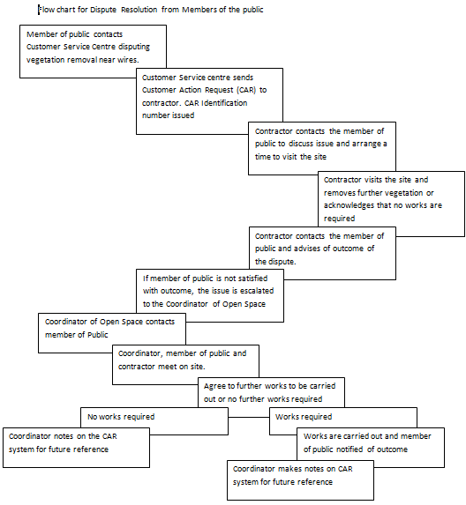Figure 1: Flow chart for Dispute Resolution from members of the public

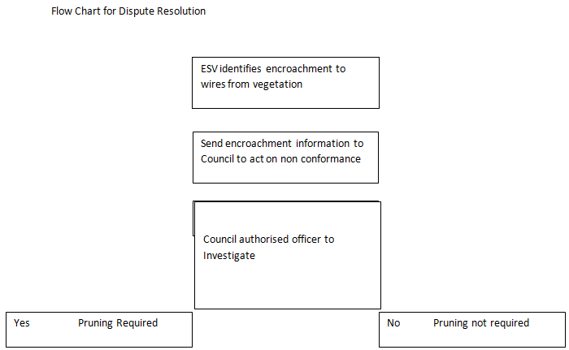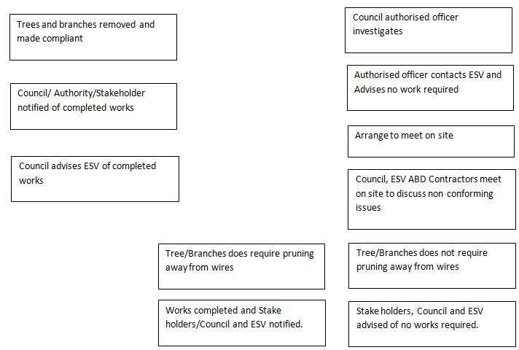Figure 2: Flow chart for dispute resolution when Regulator (ESV) has identified encroachment.

Throughout the process, Council may contact complainants to discuss their concerns or to ask for more information.

1. External Dispute Resolution

If the complainant is a member of the public and Council has been unsuccessful in resolving the dispute, the complainant will be referred to the Energy and Water Ombudsman of Victoria (EWOV) and escalation to Energy Safe Victoria (ESV) as required.

# PART 2 – CLEARANCE RESPONSIBILITIES

## DIVISION 1 – ROLE OF RESPONSIBLE PERSONS

## (4) Exception to minimum clearance space for structural branches around insulated low voltage electric lines

Where a tree is identified with a structural branch within the Clearance Space >130mm in diameter and removal of the branch will significantly alter the shape of the tree or compromise its structure, Council may undertake an individual risk assessment of the tree to determine whether this exception to the normal clearance requirements is appropriate.

The Exception relates to a structural branch with a part that is >130mm diameter within the Clearance Space for spans that are:

1. Less than or equal to 40m in length and the branch is >150mm from the line, or
2. Greater than 40m in length and the branch is >300mm from the line.

If Council chooses to apply this Exception, an individual risk assessment of the tree will be undertaken annually to determine that the branch does not have a defect or otherwise pose an unreasonable risk. All assessments for trees to which this exception may be or is applied will be undertaken by an arborist with all relevant training as detailed in Part 1 [9(4)(p)](#_9(4)(p)_THE_QUALIFICATIONS) of this Plan.

All assessment records will be held as per Council’s data retention policies, and for a period of no less than 5 years.

## (5) Exception to minimum clearance space for small branches around insulated low voltage electric lines

Where it is identified that foliage and branches less than 10mm in diameter have grown within the Clearance Space of a low voltage insulated cable, the pruning records for the tree will be reviewed to ensure the tree has been pruned to comply with the minimum Clearance Space in the previous 12 months. If it has, the tree will be noted as requiring pruning during the next cycle of the annual clearance program. If it has not, the Contractor will be required to prune the tree within 7 days of receiving the non-conformance. This will not be treated as a contractual non-conformance or breach of contract.

## (6) Exception to minimum clearance space for SMALL branches around uninsulated low voltage electric lines in low bushfire risk areas

If the Council identifies any trees to which it intends to apply this exception it will list the tree on a register. For these tree/s it will not be required to ensure that a particular branch of a tree for which it has clearance responsibilities is clear of the minimum clearance space for a span of an electric line if:

* The electric line is:
* An uninsulated cable; and
* A low voltage electric line; and
* The branch is less than 10 mm at the point at which it enters the minimum clearance space; and
* The branch is no more than 500mm inside the minimum clearance space; and
* The point at which the branch originates is below the height of the electric line; and
* In the case of a branch that comes within the minimum clearance space around the middle 2 thirds of the span, the span is fitted with—

(i) one conductor spreader if the length of the span does not exceed 45 metres; or

(ii) 2 conductor spreaders if the length of the span exceeds 45 metres; and

* the responsible person has completed an assessment of the risks posed by the branch; and
* the responsible person has implemented measures to effectively mitigate the identified risks.

All assessment records will be held as per Council’s data retention policies, and for a period of no less than 5 years.

## (7) Exception to minimum clearance space for structural branches around uninsulated low voltage electric lines in low bushfire risk areas

Where a tree is identified with a structural branch within the Clearance Space >130mm in diameter and removal of the branch will significantly alter the shape of the tree or compromise its structure, Council may undertake an individual risk assessment of the tree to determine whether this Exception to the normal clearance requirements is appropriate.

This Exception relates to a structural branch with a part that is >130mm diameter within the Clearance Space for spans that are:

1. Less than 45m in length, contain one conductor spreader and the branch is >500mm from the line, or
2. Greater than 45m in length, contains two conductor spreaders and the branch is >500mm from the line.

If Council chooses to apply this Exception, an individual risk assessment of the tree will be undertaken annually to determine that the branch does not have a defect or otherwise pose an unreasonable risk. All assessments for trees to which this exception may be or is applied will be undertaken by an arborist with all relevant training as detailed in Part 1 [9(4)(p)](#_9(4)(p)_THE_QUALIFICATIONS) of this Plan.

All assessment records will be held as per Council’s data retention policies, and for a period of no less than 5 years.

## (8) Owner or operator of transmission line must manage trees around minimum clearance space

The City of Melton is not an owner or operator of transmission lines and is therefore not responsible for electrical clearance of vegetation around transmission lines.

## (9) Responsible person may cut or remove hazard tree

Council is responsible for pruning or removing urgent trees under powerlines. After undertaking the work, Council will is required to notify;

1. All affected persons and
2. The occupier of the land on which the tree was cut or removed and
3. If a tree was removed – the owner of the land on which the tree was removed

Council’s service provider provides a letter to the home owner at the time of pruning or removal an example of the notice is included in Appendix 2.

The Contractor engaged for urgent pruning or removal will record all urgent works and completion of the notification requirement in the Customer Action Request System including;

1. Where and when the cutting or removal was undertaken,
2. Why the cutting or removal was required,
3. The last inspection of the section of the electric line where the cutting or removal was required.

Where the urgent cutting or removal is required;

1. As a result of the encroachment or growth of trees that was not anticipated in the management plan or,
2. During the fire danger period declared under the Country Fire Authority Act 1958.

The Contractor engaged for urgent cutting or removal as a result of unanticipated regrowth, will not remove or cut the trees further than 1 metre from the minimum clearance space around the electric line and will notify the affected person/s after the works have been carried out using the form in Appendix 2.

Records of all urgent works and completion of the notification requirement will be provided to Council as part of the Contractor’s monthly report.

# PART 2 – CLEARANCE RESPONSIBILITIES

## DIVISION 2 – MANNER OF CUTTING AND REMOVING TREES

## (9) Responsible Person may cut or remove hazard trees

Please see [Part 1, 9(4)(j)](#_9_(4)(j)_THE) herein.

## (10) Cutting of tree to comply with Standard

Please see [Part 1, 9(4)(j) and 9(4)(k)](#_9(4)(k)_THE_PROCEDURES) herein.

## (11) Cutting or removal of indigenous or significant trees must be minimised

Please see [9(4)(h)](#_9(4)(h)_EACH_AREA) and [9(4)(i)](#_9(4)(i)_DETAILS_OF) herein.

## (12) Cutting or removing habitat for threatened fauna

Please see [9(4)(i)](#_9(4)(i)_DETAILS_OF) herein.

## PART 2 – CLEARANCE RESPONSIBILITIES

## DIVISION 3 – NOTIFICATION, CONSULTATION AND DISPUTE RESOLUTION

## (16) Responsible person must publish notice before cutting or removing certain trees

Please see [9(4)(q)](#_9(4)(q)_NOTIFICATION_AND) herein.

## DIVISION 4 – ADDITIONAL DUTIES OF RESPONSIBLE PERSONS

## (20) Duty relating to the safety of cutting or removal of trees close to an electric line

Where Council and its Contractor are unsure of the safety of pruning or removing a tree, they will consult with the relevant Distribution Business, or if the tree affects a railway supply line, the relevant Railway Operator, to develop an appropriate action plan to mitigate the hazard or bring the tree into compliance with the Code.

The contact details of the relevant organisations are provided at the beginning of this Plan.

(21) Duty relating to assisting to determine the allowance for conductor sag and sway

Notwithstanding other requirements of this clause, Council notes that an owner, operator or distribution company that is consulted by a Council under subclause 21(1) of the Regulations must assist the Council by determining the additional distance. Council will keep a record of the information provided, including the additional sag and sway distances for at least 5 years.

# PART 3 – MINIMUM CLEARANCE SPACES

## DIVISION 2 - ALTERNATIVE COMPLIANCE MECHANISMS

## (31) Application for approval of alternative compliance mechanism

Council does not currently hold approval for, nor intend to use any alternative compliance mechanisms.

If Council should apply to Energy Safe Victoria for approval to use an alternative compliance mechanism in respect of a span of an electric line or a class of spans, the application will contain details including:

(i) the alternative compliance mechanism; and

(ii) a written confirmation from the Distribution Business or alternative qualified provider that includes;

1. the procedures to be adopted for commissioning, installing, operating, maintaining and decommissioning the alternative compliance mechanism; and
2. the published technical standards that will be complied with when commissioning, installing, operating, maintaining and decommissioning the alternative compliance mechanism; and
3. specify the location of the span of electric line; or describe the class; and

d) the minimum clearance space proposed is to be applied in relation to the span, or class of spans, in respect of which the application is made; and

e) a copy of the formal safety assessment prepared by the Distribution Business or an alternative qualified provider under clause 32.

(iii) a copy of the written agreement of the owner or the operator of the span; or the owner or the operator of each span that belongs to that class.

## (32) Formal safety assessment of alternative compliance mechanism

As Council Officers are not qualified to provide a formal safety assessment, this will be prepared by the Distribution Business or an alternative qualified provider and will comply with the requirements as defined in Schedule1, part 3, Division 2, and Clause 1 of the Code.

# APPENDIX 1 – DECLARED AREA MAPS (1 of 3)

**Melton/Melton South**

**Hatched regions are the Declared Area. North is top of map as per convention.**

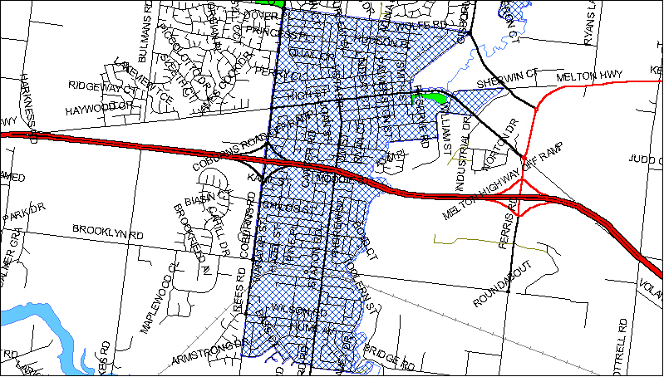

Legend

Declared Area

Open Space

See Map 2 for continuation of this area

# APPENDIX 1 – DECLARED AREA MAPS (2 of 3)

**Kurunjang East**

**Hatched regions are the Declared Area. North is top of map as per convention.**

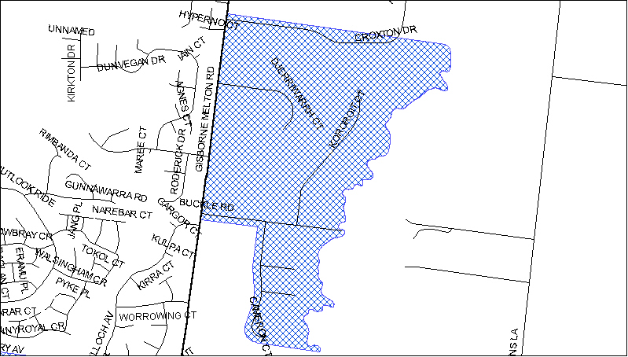

# APPENDIX 1 – DECLARED AREA MAPS (3 of 3)

**Diggers Rest**

**Hatched regions are the Declared Area. North is top of map as per convention.**

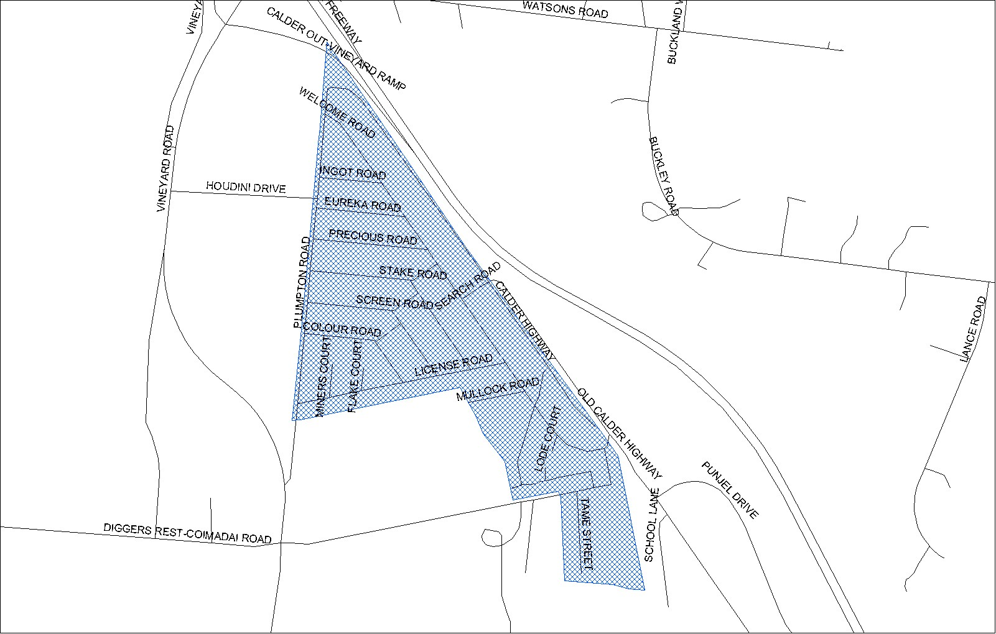

# APPENDIX 2 - Notice of Urgent Cutting or Removal of Tree from unexpected regrowth or other reasons as per Clause 17 (2) (a), (b) and Clause 3 (a),(b),(c) of Electricity Safety (Electric Line Clearance) Regulations 2020

|  |
| --- |
| **City of Melton**  **232 High Street, Melton 3337 (PO Box 232 High Street)**  **Tel: 9747 7200**  **Web: www.melton.vic.gov.au** |
| **CITY OF MELTON**  **NOTICE OF URGENT TREE CUTTING OR REMOVAL**  Dear Occupier of ................................Street, ................................., and/or affected persons  Under Clause 6 of the Electricity Safety (Electric Line Clearance) Regulations 2020, the tree adjacent to your property has been deemed to require urgent cutting or removal.  The works have been undertaken in accordance with the regulations. |
| If you have any queries about the works undertaken, please contact Council on 9747 7200.  Thank you  Date: .......................  Council Representative........................... |

# APPENDIX 3 - Applicable distance for middle two thirds of electric line span

**GRAPH 1—INSULATED ELECTRIC LINES IN ALL AREAS**

*(Extracts from Electrical Safety (Line Clearance) Regulations 2020)*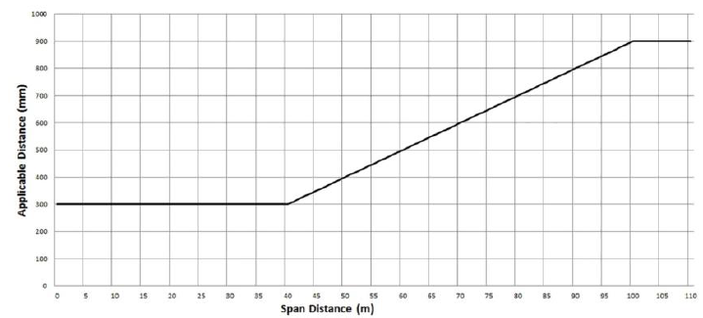

|  |
| --- |
| The formula by which the applicable distance for the middle two thirds of a span of an insulated electric line in all areas is calculated is as follows:  The applicable distance for the middle two thirds of the span is:  A. if the span distance is less than or equal to 40 m the applicable distance equals 300 mm  B. if the span distance is greater than 40 m and less than or equal to 100 m — the applicable distance is calculated in accordance with the following expression — 300 + [(span distance minus 40) multiplied by 10];  C. if the span distance is greater than 100 metres the applicable distance equals 900 mm. |

**GRAPH 2: UNINSULATED LOW VOLTAGE ELECTRIC LINE IN LOW BUSHFIRE RISK AREA**

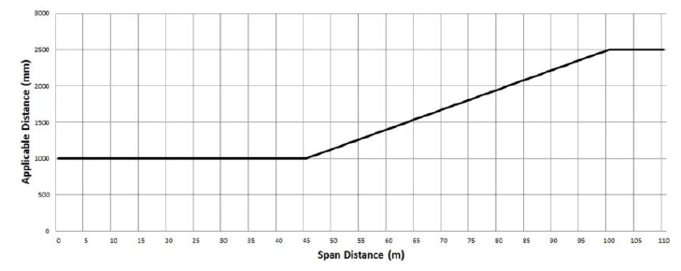

|  |
| --- |
| The formula by which the applicable distance for the middle two thirds of a span of uninsulated low voltage electric line in a low bushfire risk area is calculated is as follows  A if the span distance is less than or equal to 45 m the applicable distance equals 1000 mm  B. If the span distance is greater than 45 m and less than or equal to 100 m the applicable distance is calculated in accordance with the following expression: 1000 + [(span distance minus 45) multiplied by (1500 divided by 55)];  C. if the span distance is greater than 100 m the applicable distance equals 2500 mm. |

**GRAPH 3: UNINSULATED HIGH VOLTAGE ELECTRIC LINE (OTHER THAN A 66,000 VOLT ELECTRIC LINE) IN LOW BUSHFIRE RISK AREA** 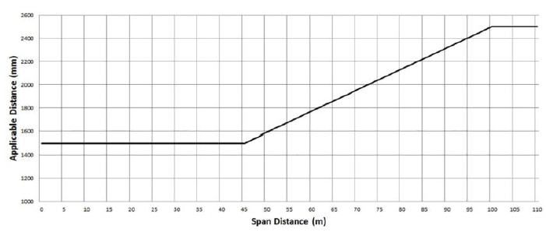

|  |
| --- |
| The formula by which the applicable distance for the middle two thirds of a span of uninsulated high voltage electric line (other than a 66,000-volt electric line) in a low bushfire risk area is calculated is as follows:  A. if the span distance is less than or equal to 45 m the applicable distance equals 1500 mm  B. if the span distance is greater than 45 m and less than or equal to 100 m, the applicable distance is calculated in accordance with the following expression 1500 + [(span distance minus 45) multiplied by (1000 divided by 55)]  C. if the span distance is greater than 100 m the applicable distance equals 2500 mm. |

**GRAPH 4: UNINSULATED 66,000 VOLT ELECTRIC LINE IN LOW BUSHFIRE RISK AREA**

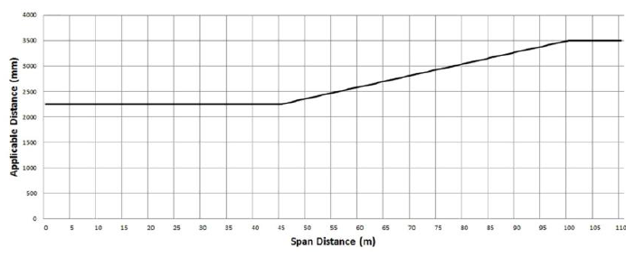

|  |
| --- |
| The formula by which the applicable distance for the middle two thirds of a span of uninsulated 66,000-volt electric line in a low bushfire risk area is calculated is as follows:  A. if the span distance is less than or equal to 45 m the applicable distance equals 2250 mm  B. if the span distance is greater than 45 m and less than or equal to 100 m the distance calculated in accordance with the following expression 2250 + [(span distance minus 45) multiplied by (1250 divided by 55)]; or C. if the span distance is greater than 100 m the applicable distance equals 3500 mm. |

**GRAPH 5: UNINSULATED LOW VOLTAGE AND HIGH VOLTAGE ELECTRIC LINE (OTHER THAN A 66,000 VOLT ELECTRIC LINE) IN HAZARDOUS BUSHFIRE RISK AREA**

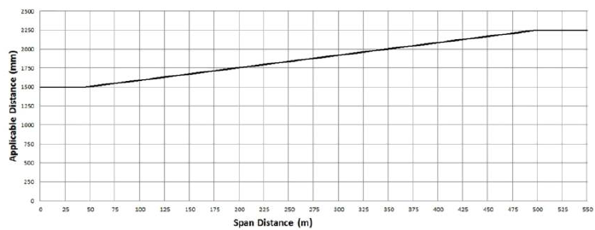

|  |
| --- |
| The formula by which the applicable distance for the middle two thirds of a span of an electric line is calculated is as follows:  A. if the span distance is less than or equal to 45 m the applicable distance equals 1500 mm  B. if the span distance is greater than 45 m and less than or equal to 500 m, the applicable distance is calculated in accordance with the following expression 1500 + [(span distance minus 45) multiplied by (500 divided by 303)]; or C. if the span distance is greater than 500 m the applicable distance equals 2250mm |

**GRAPH 6: UNINSULATED 66,000V ELECTRIC LINE IN HAZARDOUS BUSHFIRE RISK AREA**

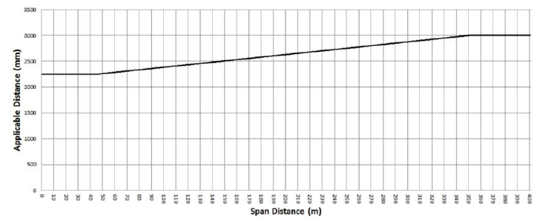

|  |
| --- |
| The formula by which the applicable distance for the middle two thirds of a span of an electric line is calculated is as follows:  A. if the span distance is less than or equal to 45 m the applicable distance equals 2250 mm  B. if the span distance is greater than 45 m and less than or equal to 350m, the applicable distance is calculated in accordance with the following expression 2250 + [(span distance minus 45) multiplied by (750 divided by 305)]; or C. if the span distance is greater than 350 m the applicable distance equals 3000mm |

|  |  |
| --- | --- |
| **FIGURE 1 – PLAN VIEW OF ELECTRICAL LINES IN ALL AREAS** | **FIGURE 2 – INSULATED ELECTRICAL LINES IN ALL AREAS**  . |
| **FIGURE 3 – INSULATED ELECTRICAL LINES IN ALL AREAS AND UNINSULATED HIGH VOLTAGE ELECTRICAL LINES (OTHER THAN 66 000 VOLTAGE ELECTRIC LINES) IN LOW BUSHFIRE RISK AREAS** | **FIGURE 4 – UNINSULATED LOW VOLTAGE ELECTRICAL LINES IN LOW BUSHFIRE RISK AREAS** |
| **FIGURE 5 – UNINSULATED 66 000 VOLTAGE ELECTRICAL LINE IN A LOW BUSHFIRE RISK AREA AND UNINSULATED ELECTRIC LINE IN A HAZARDOUS BUSHFIRE RISK AREA** |  |