Application for Radio Control Model or Vehicle Permit
- Applicant details (applicant must be over the age of 18 years)
Name
Street address
 |  |  |  |  | Postcode
Phone number |  | Mobile number
Email address
- General details
What type of radio control model/ vehicle do you have? | If other, please specify
  Car | Boat | Plane | Helicopter | Other
How many radio control model/vehicles do you have? | 1 More than 1 – Please complete section 4
Dimensions | Height |  |  | Length |  |  | Width
How is it motorised? | Electric Petrol/fuel Other  If other, please specify
Which reserve?
Which days? | Mon Tue Wed Thu Fri Sat Sun
Time of arrival |  |  | Time of departure

- Additional details
New permit Permit renewal Code 517
- This application is for the use of a radio controlled model or vehicle within a Reserve in the Melton municipality.
- Please include a photograph and any further specifications of your radio control model or vehicle with this application.
- Your application will not be processed unless the application is fully completed. Incomplete applications will not be accepted.
- Council will issue a permit with specified conditions that must be adhered to at all times and may cancel a permit at anytime for any breaches.
- Hours of use will be 10am to 6pm during daylight savings and 10am to 5pm at other times
- A permit will be valid for 12 months upon being issued. This permit is non-transferable and must be carried with you at all times when using a radio control model or vehicle in a Melton City Council Reserve area.
- If you are applying for a new permit please submit the application 28 days prior to using a radio controlled model or vehicle in a Reserve. For all permit renewals please complete this form and submit it at least 28 days before the expiry date of the existing permit.

Please return completed form to:
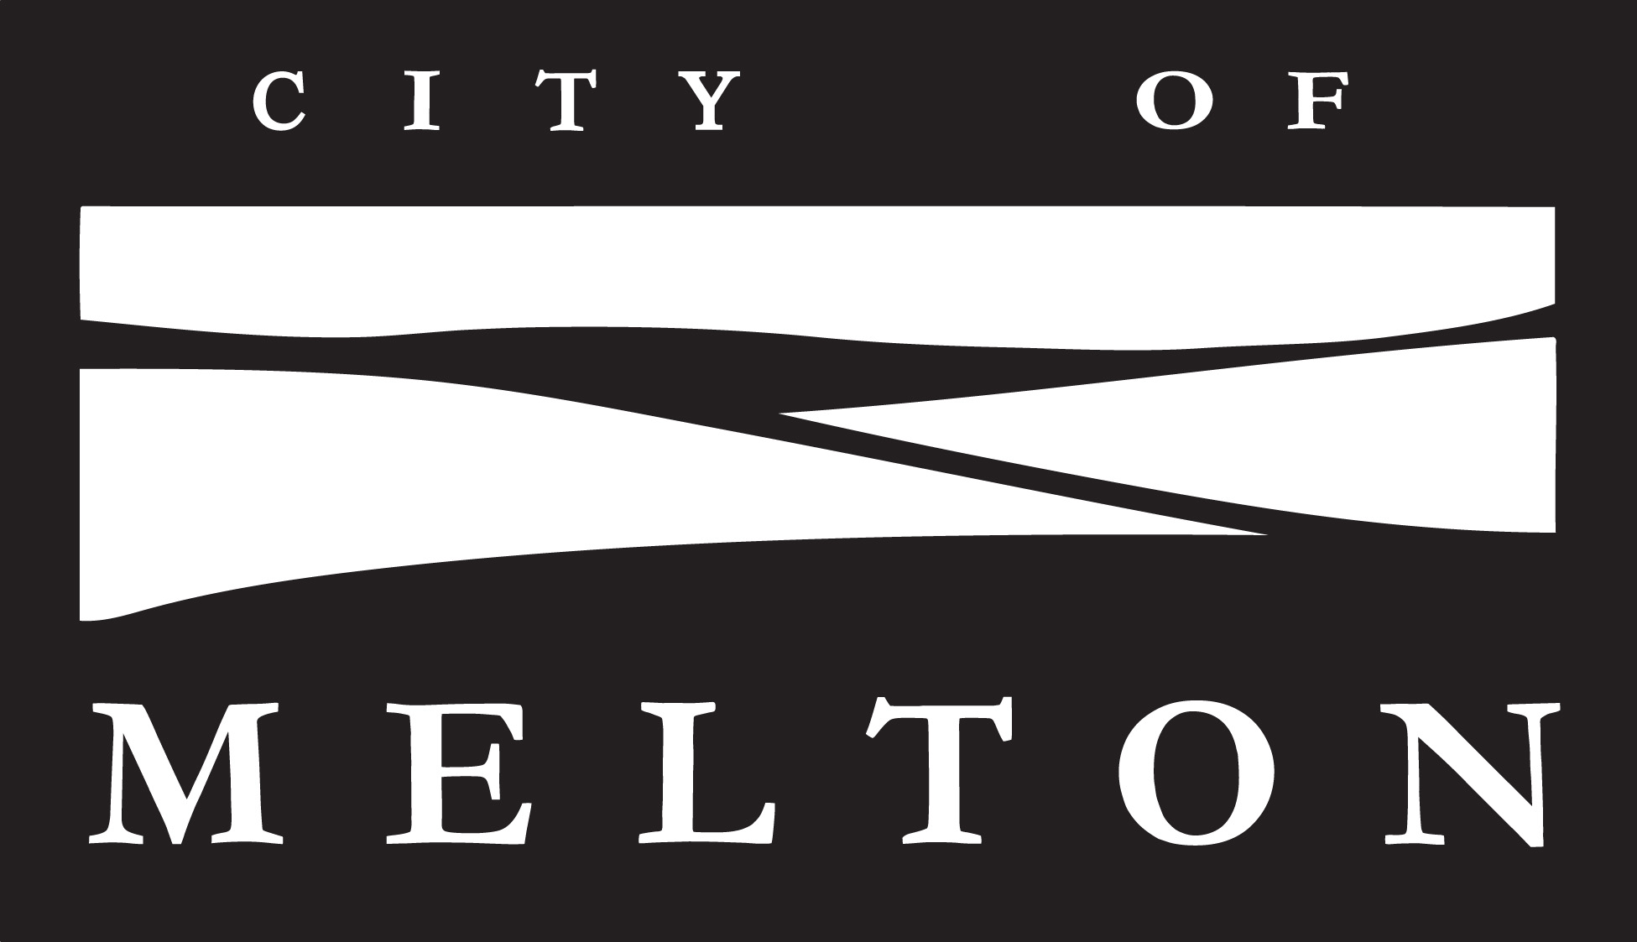
Mail: Email: Phone:
Melton City Council csu@melton.vic.gov.au 9747 7200
PO Box 21, (max. file size: 10MB) Fax:
Melton VIC 3337 9743 9970

- Multiple Radio Control Model/Vehicle details

Second Model/Vehicle details
What type of radio control model/ vehicle do you have? | If other, please specify
  Car | Boat | Plane | Helicopter | Other
Dimensions | Height |  |  | Length |  |  | Width
How is it motorised? | Electric Petrol/fuel Other  If other, please specify
Which reserve?
Which days? | Mon Tue Wed Thu Fri Sat Sun
Time of arrival |  |  | Time of departure

Third Model/Vehicle details
What type of radio control model/ vehicle do you have? | If other, please specify
  Car | Boat | Plane | Helicopter | Other
Dimensions | Height |  |  | Length |  |  | Width
How is it motorised? | Electric Petrol/fuel Other  If other, please specify
Which reserve?
Which days? | Mon Tue Wed Thu Fri Sat Sun
Time of arrival |  |  | Time of departure

Please note: If you have more than 3 models/vehicles, please complete another application form.

- Declaration

I (name) _________________________ of (address) ___________________________________________________
in the state of Victoria do solemnly and sincerely declare that the radio control model/vehicle is owned/operated by me and that the information supplied is true and correct.
Signature | Date
_________________________________________ | ___________________

Privacy Statement: The personal information requested on this form is being collected by Council for the purpose of meeting its legal obligations under the Road Safety Act1986, Environment Protection Act 1970, Summary Offences Act 1966, Local Government Act 1989, Impounding of Livestock Act 1994, Domestic Animals Act 1994, Infringements Act 2006 and associated or related legislation. The information will be kept confidential and identifying information will not be disclosed to any person for any other purpose. You may access your own information by contacting Council's Local Laws unit on 9747 7200.

