Application for Military Commemoration Investment

Organisations and community groups are invited to apply for support from Council for projects within the municipality aimed at commemorating our nation’s military heritage. These projects may include (but not limited to):
- Restoration and protection of war memorials across the City of Melton.
- Raising community awareness of the service and sacrifice of Australian men and women during the war.
- Contributing to a program of diverse, inclusive and educative projects and activities.
- Encouraging community participation and engagement.
- Promoting social, cultural and economic benefit to the community.
Who can apply:
Applicants must be based within the City of Melton.
Applications are invited from:
- Individuals;
- Ex-service organisations;
- Local government authorities;
- Community organisations;
- Special interest groups;
- Researchers;
- Educational institutions;
- Parent groups; and
- Not for profit organisations.
If you have any questions or require further information, phone the Events team on 9747 7200 or email events@melton.vic.gov.au
The Military Commemoration Investment Advisory Committee will meet bi-annually in February and August. Your application will be assessed at the next available meeting upon receipt. Please be advised we require your completed application 3 weeks prior to the meeting for it to be processed.

- Your details
Respondent’s name
Business or group name |  |  | ABN
Mailing address
 |  |  |  | Postcode
Business address
 |  |  |  | Postcode
Phone number |  | Mobile number
Email address |  | Web site
Event day contact person |  | Mobile number
- Proposal
Please provide a description of what how you are proposing to commemorate military heritage. Please specify if the support you seek from Council is in-kind, monetary, or support via event services etc.
Proposed project date: __________________________

Do you require Mayoral involvement? € Yes € No
If yes in what capacity?

€ Request for Mayor to speak € Request for Mayor to attend as a guest
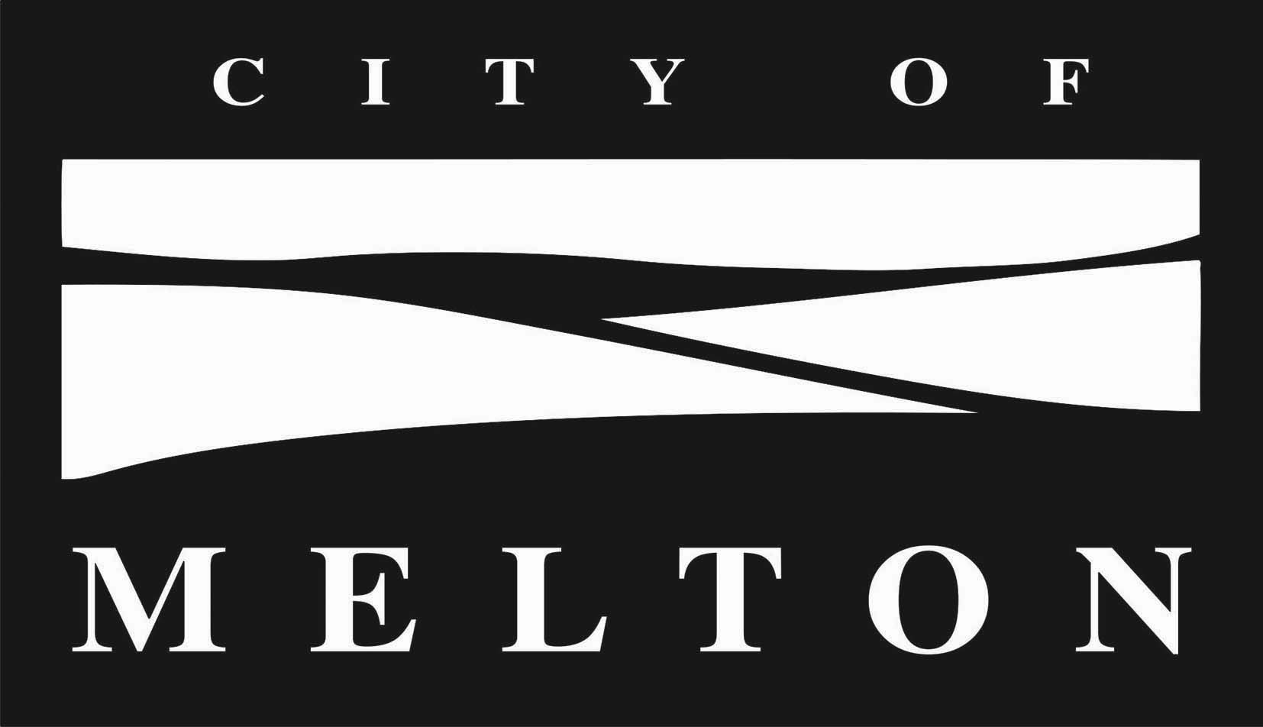

Please return your completed form and supporting documentation to:
Mail:Email:Phone:
Events and Cultureevents@melton.vic.gov.au9747 7200
PO Box 21, (max. file size: 5MB)Fax: 9743 9970
Melton VIC 3337

In the instance your proposal relates to an event, have you run this event previously?
€ Yes € No
If yes please provide further details

If you seek monetary support from Council please detail the amount and proposed community benefit below

If you seek material and/or technical support from Council please specify below

- Supporting documentation
If your submission is successful do you agree to provide Melton City Council with:
€ Operations Plan
€ Proposed Sitemap (if applicable)
€ Risk Management Report
- Principal’s Indemnity
The applicant agrees to abide by all terms and conditions and to indemnify and keep indemnified the Principal, its servants and agents, from and against all actions, costs, claims, charges, expenses, penalties, demands and damages whatsoever that may be brought or made or claimed against them, or arising from my performance or purported performance of its obligations and directly related to the negligent acts, errors or omission by the applicant and their involvement with Melton City Council Festivals.
Signature of applicant |  |  | Date
Privacy Statement: The personal information requested on this form is being collected by Melton City Council for the purpose of coordinating the Events. The information will be kept confidential and identifying information will not be disclosed to any person for any other purpose. You may access your own information by contacting Melton City Council’s Customer Engagement Unit on 9747 7200.

