|  |
| --- |
| Melton logo colour (2).jpgMelton City Council Vacation Care Program **Checklist - What to Bring** |

|  |  |
| --- | --- |
| **To ensure you are fully prepared and able to participate in all of the activities on offer, the items on the below check list are required each day.** | **Tick**  **✓** |
| **A bag that is able to hold all of your belongings (e.g. school bag).** *If we have room to keep all of our belongings together it is less likely we will lose things.* |  |
| **A refillable drink bottle.** *Our bodies are 97% water, we need to keep hydrated.* |  |
| **Healthy snacks for morning tea, lunch and afternoon tea.** *We have busy days and need to fuel our bodies often and with the best possible fuel.* |  |
| **Sun protective hat and clothing** (A wide brimmed, bucket or legionnaire style. NO CAPS. Wear clothes which cover shoulders and thighs)*We are SunSmart, so… you won’t be able to go outside without it.* |  |
| **Appropriate footwear** (trainers or closed toe shoes). *Being so active, we want to avoid injuring our feet, trip or fall.* |  |
| **Any prescribed medication + Action Plans** (Asthma Pumps, EpiPen). *You can attend only with your medication and completed up to date medical action plan. Blank forms are available under our Children’s Services policies and procedures on the website.* |  |
| **Wear ‘play clothes’ and we recommend a spare change.** *We get messy, muddy and wet during play - plus accidents do happen. We will not restrict children from messy activities so please come prepared.* |  |
| **Well rested and open minds.** *Sleep is essential for growing minds, bodies and a happy disposition – come rested and ready for fun.* |  |

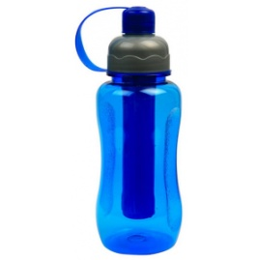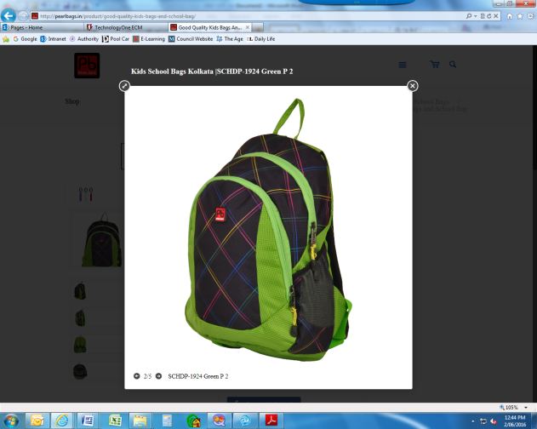

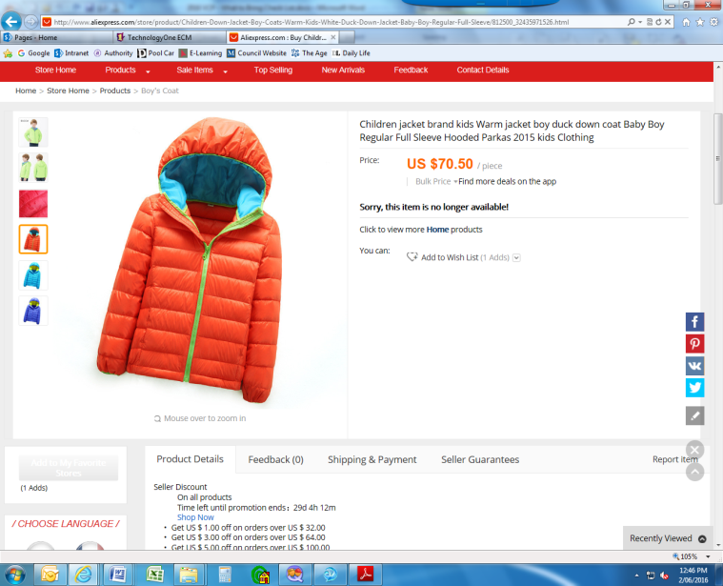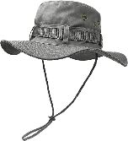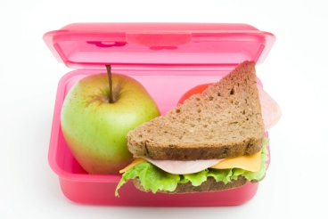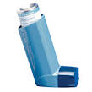

*The above list was compiled from the Children’s Services Policies and Procedures which can be found at the Melton City Council website (melton.vic.gov.au) by selecting Children under the Services tab.*