Melton Planning Scheme

**Statement of Significance: 115-131 Napier Street, 480-580,726-738,740-794 and 796-830 Mt Aitken Road, Diggers Rest “Mt Aitken Soldier Settlement Housing”, June 2022**

|  |  |  |  |
| --- | --- | --- | --- |
| **Heritage Place:** | Housing  115-131 Napier Street, 480-580, 726-738, 740-794 and 796-830 Mt Aitken Road, Diggers Rest | **PS ref no:** | HO141 |

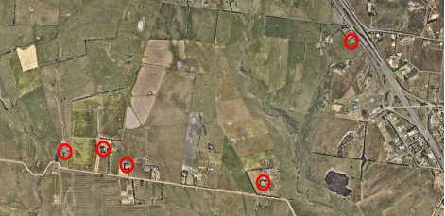

Note: the property at 740-794 Mt Aitken Road, Diggers Rest is included in the Heritage Overlay of the Melton Planning Scheme as HO60 – Mount Aitken Site and Ruin. This citation relates only to the Soldier Settlement house on this property. No assessment has been undertaken of the former Mt Aitken remains.

**What is significant?**

The four soldier settlement houses on Mt Aitken Road and one on Napier Street, Diggers Rest are part the post-World War II farm settlement scheme for ex-servicemen. The small farming allotments were formerly part of the Mt Aitken pastoral estate and were acquired by the State Government in 1947. Five men who had served in various roles during World War II successfully applied to occupy the allotments – A1, A2, A3, A4 and A5. The farmhouses of this scheme were of a standard type, typically modest single-storey weatherboard construction, stepped frontages and entry porches. The subject residences are understood to have been constructed to the standard designs by architects Buchan, Laird and Buchan, and were constructed in the early 1950s. The five soldier settlement properties were acquired as freehold by ex-servicemen during the 1960s and 1970s, indicating the requirements of the scheme had been satisfied.

**How is it significant?**

Mt Aitken Estate Soldier Settlement Housing is of local historical, rarity and representative significance at a local level to the City of Melton.

**Why is it significant?**

The Mt Aitken Estate Soldier Settlement Housing is of local historical significance demonstrating the break-up of large nineteenth century pastoral estates in the municipality, and the twentieth century shift to small farm holdings. The soldier settlement houses are also of historical significance, illustrating post-war soldier settlement schemes in Melton (Criterion A).

The five soldier settlement houses constructed in the early 1950s on Mt Aitken Road and Napier Street are of local significance for their rarity as one of a small number of remaining examples of post-war soldier settlement in the municipality (Criterion B).

The five soldier settlement houses on Mt Aitken Road and Napier Street are of local representative significance for their demonstration of the key characteristics of standard soldier settlement housing. This includes their modest, single-storey weatherboard construction, often double or triple fronted, and with verandahs and brick chimneys. The designs were provided by the architects Buchan, Laird and Buchan for the Solider Settlement Commission (Criterion D).

**Primary source**

*City of Melton Heritage Assessment Project 2020/21: Findings, Lovell Chen*

This document is an incorporated document in the Melton Planning Scheme pursuant to section 6(2)(j) of the *Planning and Environment Act 1987*