Melton Planning Scheme

**Statement of Significance: Bridge over Toolern Creek, Kurunjang, “Minns Road Timber Bridge”, June 2022**

|  |  |  |  |
| --- | --- | --- | --- |
| **Heritage Place:** | Bridge  Over Toolern Creek, Kurunjang | **PS ref no:** | HO140 |

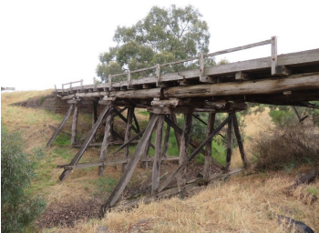

**What is significant?**

Minns Road timber bridge is a four span timber bridge which crosses Toolern Creek on the original alignment of Minns Road. Constructed in 1888, Minns Road timber bridge is comprised of three piers made up of four piles with transverse cross bracing and additional angled support piles to each side. Round timber stringers and substructure support a timber deck with a low timber balustrade extending partway along the length of the deck to both sides. Capped bluestone abutments support the east and west ends of the bridge.

**How is it significant?**

Minns Road timber bridge is of local historical, rarity and representative significance to the City of Melton.

**Why is it significant?**

Minns Road timber bridge is historically significant as a timber road bridge constructed in the late 1880s on the original alignment of Minns Road. This thoroughfare, dating from the mid-1850s, was named after the locally important Minns family. The timber bridge was built to provide local access over Toolern Creek and demonstrates the growth of the community at the time and the need to provide reliable transport connections for local residences and farming communities (Criterion A). The bridge also has associations with the locally prominent Minns family, who were well known in Melton community having owned a significant amount of land from the 1860s, as well as operated the Minns Hotel in Melton and sat on Melton Shire Council across several generations. (Criterion A) Minns Road timber bridge is a relatively rare example of a late 1880s timber road bridge constructed to provide local access, unrelated to major transport routes through Melton. It is a simple utilitarian structure which is representative of the characteristics of a late nineteenth century local access road bridge. (Criteria B and D).

**Primary source**

*City of Melton Heritage Assessment Project 2020/21: Findings, Lovell Chen*

This document is an incorporated document in the Melton Planning Scheme pursuant to section 6(2)(j) of the *Planning and Environment Act 1987*