Melton Planning Scheme

**Statement of Significance: 1809-1859 Gisborne-Melton Road, Kurunjang, “The Oaks Homestead”, June 2022**

|  |  |  |  |
| --- | --- | --- | --- |
| **Heritage Place:** | Bluestone ruin  1809-1859 Gisborne-Melton Road, Kurunjang | **PS ref no:** | HO138 |

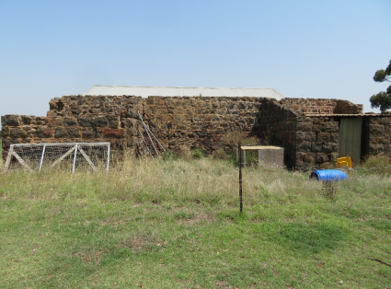

**What is significant?**

The farm ruin at 1809-1859 Gisborne-Melton Road, Kurunjang, is the remains of a relatively large bluestone farm structure with remnant internal walls and window details. It is evidence of a relatively substantial farming operation within the property from the 1860s or 1870s.

The corrugated iron gabled roof farm building is not of significance.

**How is it significant?**

The farm ruin at 1809-1859 Gisborne-Melton Road, Kurunjang is of local historical significance to the City of Melton.

**Why is it significant?**

The farm ruin at 1809-1859 Gisborne-Melton Road, Kurunjang is of historical significance to the City of Melton. Although it is unclear whether the now ruinous bluestone farm building was associated with Frederick Newnham’s Hope Farm property, or was constructed during the ownership of the property by Henry George Minns from the early 1870s, the ruin survives as evidence and a remnant survivor of a relatively substantial farming operation in the area dating from the 1860s-70s. The property, known in the early twentieth century as The Oaks, was in the possession of the locally prominent Minns family for more than a century, from the early 1870s until the early 1980s (Criterion A).

**Primary source**

*City of Melton Heritage Assessment Project 2020/21: Findings, Lovell Chen*

This document is an incorporated document in the Melton Planning Scheme pursuant to section 6(2)(j) of the *Planning and Environment Act 1987*